**1310 - lab 9**

**graph representation**

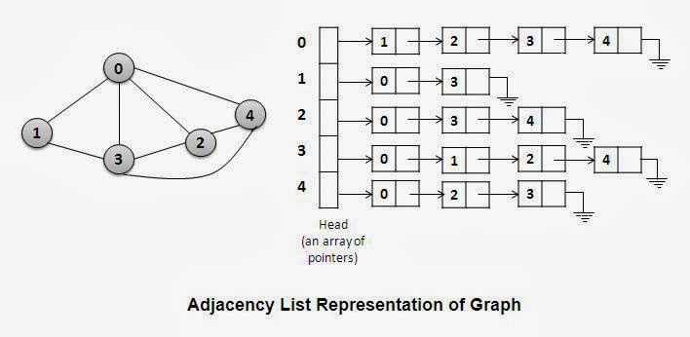

# files that should be included in your submission

* **GraphList.h**
* **Driver.cpp**
* **graph.txt**

# Given Files

* **graph.txt**

# lab specifications (directions on how to write the program)

## main.cpp

1. Open **graph.txt**
2. Read the number of vertices
3. Create your adjacency list object based on the number of vertices
4. Use a loop to read from the file the edges and add the edge to the adjacency list
   1. Make sure to print what edge is being added (refer to sample output)
5. Print the adjacency list (refer to sample output)

## GraphList.h

### Private attributes:

* ListNode structure (containing integer value & pointer to next ListNode
* ListNode ** headArray; (array of linked lists)
* int numVertices
* int numEdges

### Public Member Functions:

* **constructor** – accepts an integer (the number of vertices in the graph), sets the private attribute numVertices, dynamically allocates an array of pointers to ListNodes
* **destructor** – deletes linked lists
* **addEdge** – accepts two vertices – create the node & add it to appropriate linked list
* **printGraph** – prints the matrix

# Sample Output

There are 7 vertices in the graph.

Adding an edge from 0 to 1.

Adding an edge from 0 to 2.

Adding an edge from 1 to 4.

Adding an edge from 1 to 6.

Adding an edge from 2 to 5.

Adding an edge from 3 to 0.

Adding an edge from 3 to 1.

Adding an edge from 3 to 2.

Adding an edge from 3 to 5.

Adding an edge from 3 to 6.

Adding an edge from 6 to 4.

Adding an edge from 6 to 5.

Adjacency List...

0--->1--->2--->NULL

1--->4--->6--->NULL

2--->5--->NULL

3--->0--->1--->2--->5--->6--->NULL

4--->NULL

5--->NULL

6--->4--->5--->NULL